**POLITICAL JUGGERNAUTS**

**1.INDRODUCTION**

1.1 OVERVIEW

 something (such as a force, campaign, or movement) that is extremely large and powerful and cannot be stopped. an advertising/political juggernaut.

1.2 PURBOSE

This book ex

plains the global economy and uncovers the facts behind the hype. Globalisation is not a vehicle without a driver, or an irresistible and inevitable force of nature, as political leaders and pundits would have us believe. *Juggernaut Politics* identifies the actual institutions and people controlling the system and explains how the globalisation machine really works. It exposes the hidden face of the unregulated global market and its unequal trade treaties and domination by big money.

**2.PROBLEM DEFINITION @DESIGN THINKING**

2.1 EMPATHY MAP

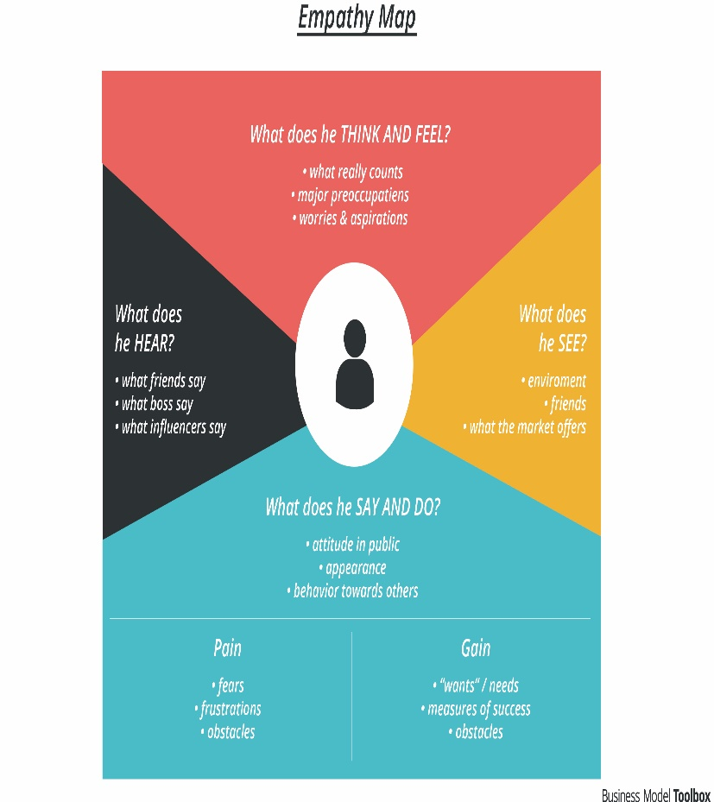

**2.2 IDEATION @BRAINSTONE MAP**

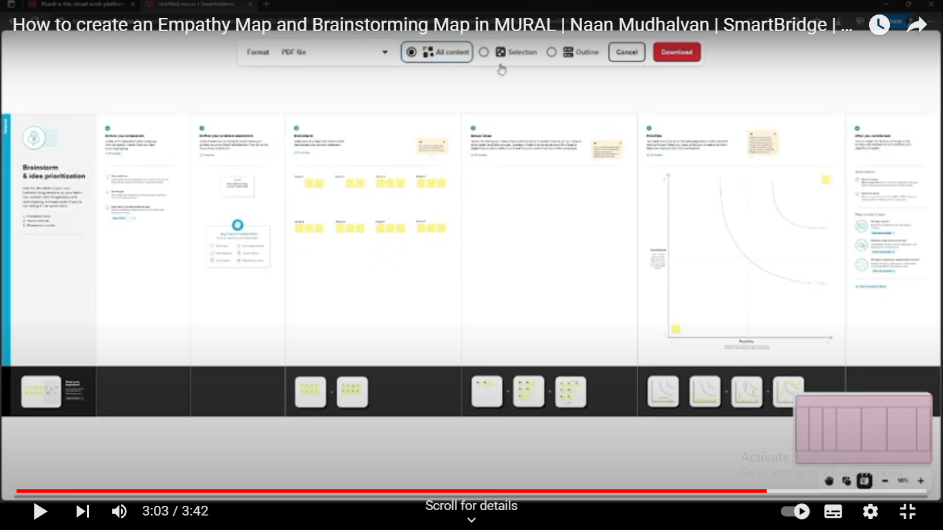

**3.RESULT**

Kamala Devi Harris made history when she became the first Indian and Black Vice President in the history of the United States in 2020. Ro Khanna, Pramila Jayapal, Ami Bera, and Raja Krisnamoorthi currently make up the so-called “Samosa Congress” in the U.S. Congress. In Canada, Jagmeet Singh’s New Democratic Party is making waves. And in the U.K., British Indians in the Boris Johnson administration, such as Priti Patel and Rishi Sunak, are enacting far-reaching immigration and economic policy. Meanwhile, Sadiq Khan serves as the mayor of London

4.ADVANTAGES &DISADVANTAGES

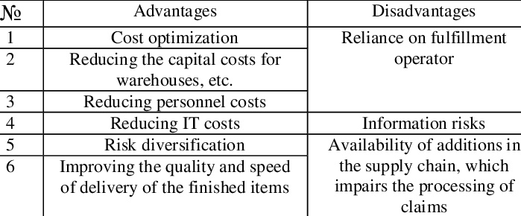

5.APLICATION

Computers have revolutionized the manner in which the political process is conducted in at least four areas: (1) computerization of political information; (2) international communication and communication between politicians and their constituencies; (3) political [data processing](https://www.encyclopedia.com/science-and-technology/computers-and-electrical-engineering/computers-and-computing/data-processing); and (4) political events simulation.

6.CONCULUSION

This course was dedicated to exploring the questions of what politics is and why it’s important. You began to work through these questions by studying a list reflecting some of the more extraordinary political events of the twentieth and twenty-first centuries. You also reflected on the more ordinary side of politics and explored the implications of politics for our day-to-day lives

7. FUTURE SCOPE

The political science scope in India is good. The role of the Policy Analyst is an example. It is one of those government jobs after ba political science, where one can get an opportunity to work with the government as well. The average salary of a Policy Analyst is 7.0 lakhs per annum